# Frontend React Developer Job

## Job Description

SERF company is looking for a good frontend developer with experience in react and a flux architecture (preferably redux).

The responsibilities for this position include:

* Ability to transform requirements document into code.
* Front end responsive web application development.

## Requirements

At least 2 years JavaScript experience with 6 months of it being in react (with a flux architecture e.g. redux) which include:

* Follow JavaScript code conventions enforced with eslint.
* ES6 familiarity.
* Ability to work with rest api’s (socket.io experience is a bonus).
* Ability to integrate into an existing code base.
* Git experience is required.
* Experience using package managers (preferably webpack).
* Experience with sass style syntax.
* Good English communication skills.

Must also have the ability to work independently but collaborate with a team.

## Assessment Task

SERF as an AI product deals with a lot of documents, we often need to tag the words in the documents. This task will simulate that process.

The final product should be a simple interface that shows a block of text with very basic formatting (paragraphs). It should be implemented in clean and well-structured React Redux application that allows the user to mark words as tags, e.g.

The steps include:

* The candidate must fetch some dummy text from the server and query i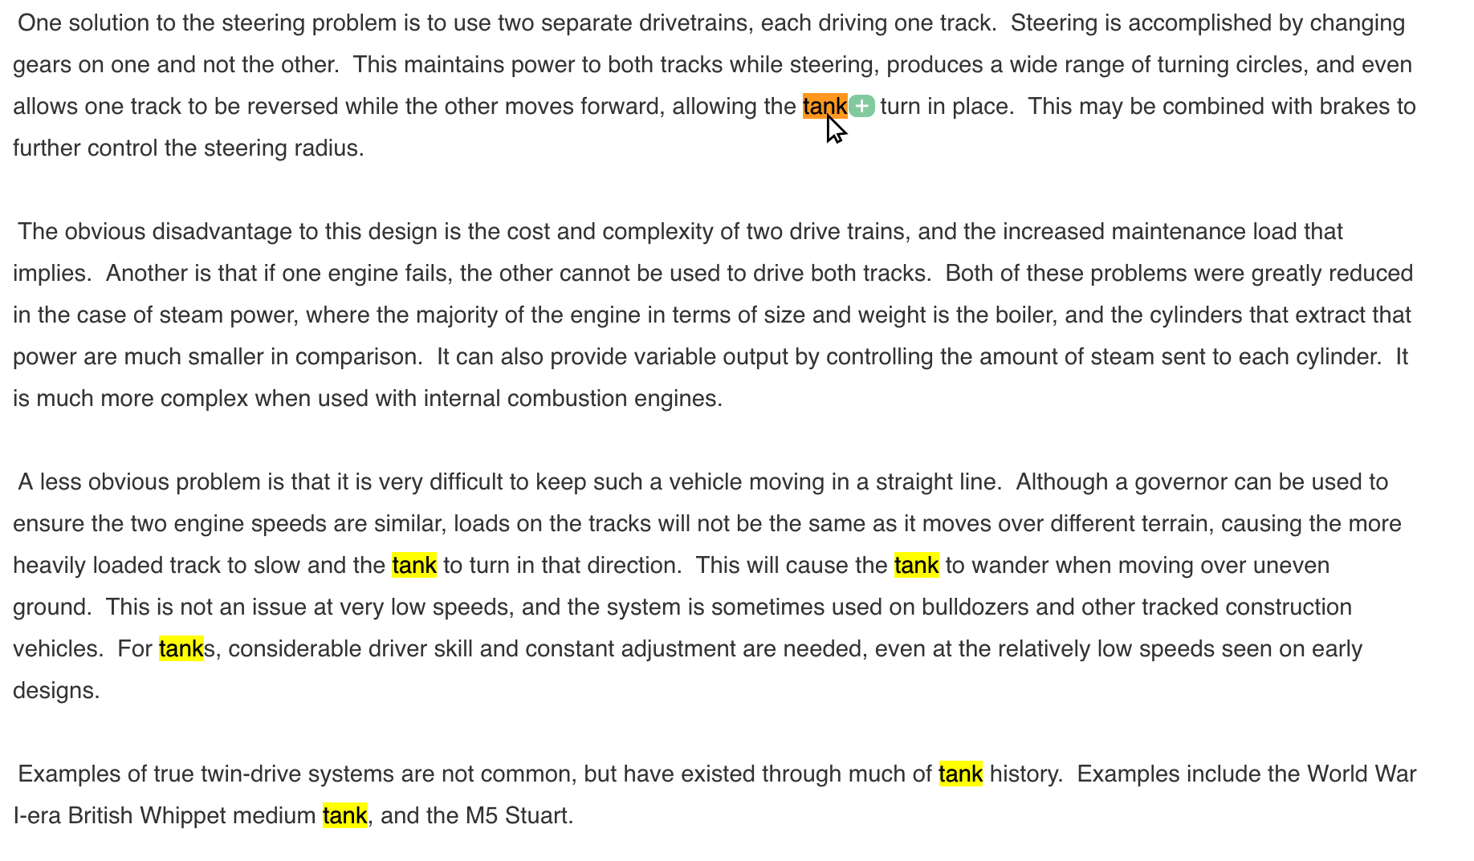f there are existing tags associated with the text.
* If tags already exist then the tags must be highlighted.
* In order the add a tag the following functionality is required:
  + User must have ability to click on a word.
  + When a word is clicked:
    - Similar words are selected.
    - An addition (+) button appears in vicinity of selected word.
  + When the addition button is clicked, the word needs to be set as a tag and saved to the server through redux thunk (or something similar) in a CRUD architecture.
  + The state of the app must be managed using immutable.js
* If the candidate has server experience, they can create the REST API endpoints to store the tags and fetch the text (keep it simple), otherwise we will provide one for them.

Note: Use different highlighting for existing tags and marked similar words for the current selection.